**Our plan -**

1. Web application using satellite image to count trees with DNN inception algorithm vertically and horizontal and providing people with useful real time information about a specific area like - number of tree, tree vs man ratio, ranking of the city/area in the whole town.
2. People in a specific location taking picture of garbage heap and upload it to the map to request for cleanup.
3. Sending notification during weekend to cleanup garbage heap near user.

**What we have done so far-**

1. We made a web page showing the feature we are going to provide

Link: [https://github.com/CS-Ponkoj](https://github.com/CS-Ponkoj?fbclid=IwAR3H_dIb-UI3qu4MRdR4HDR2g15oKw5E2IZLWLUm5CjAT12cUkillOv35XM)

1. Connected map in the webpage to visualize how the feature will be working

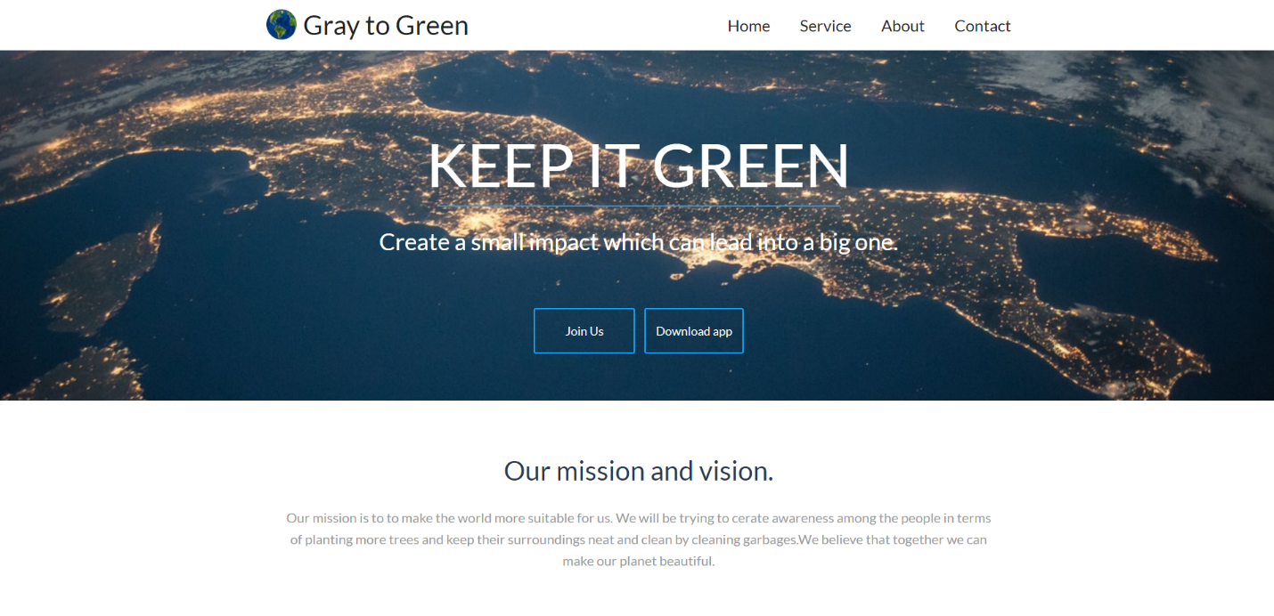

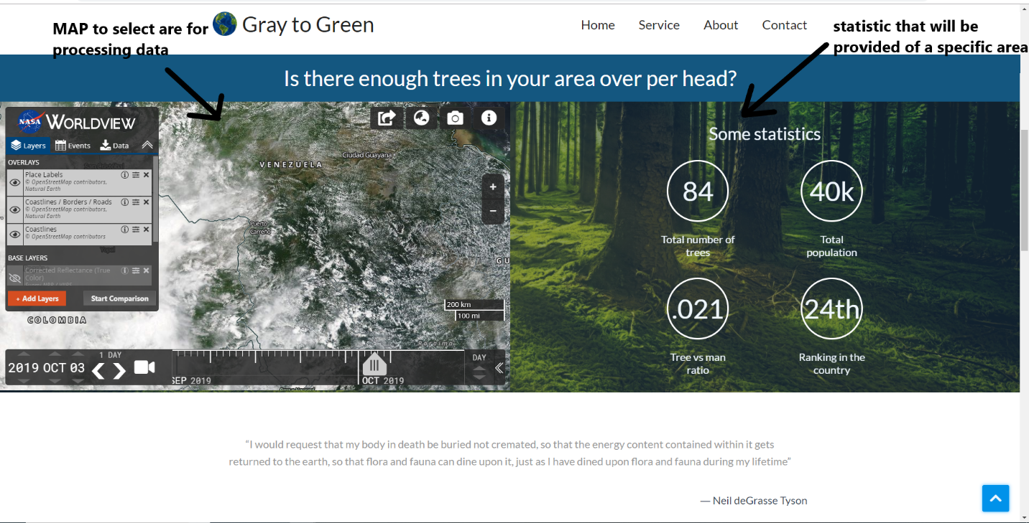

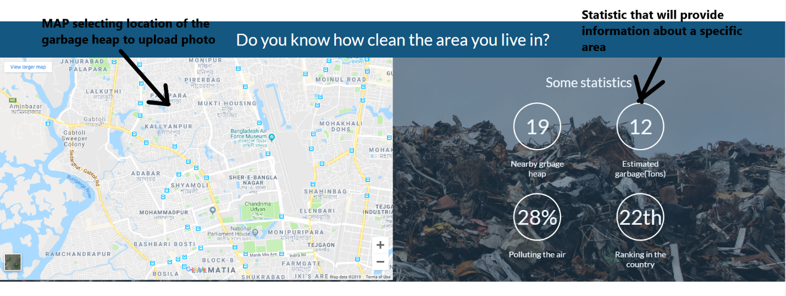

1. Connected API to surprise our user to give the awesome experience of APOD using NASA’s API.



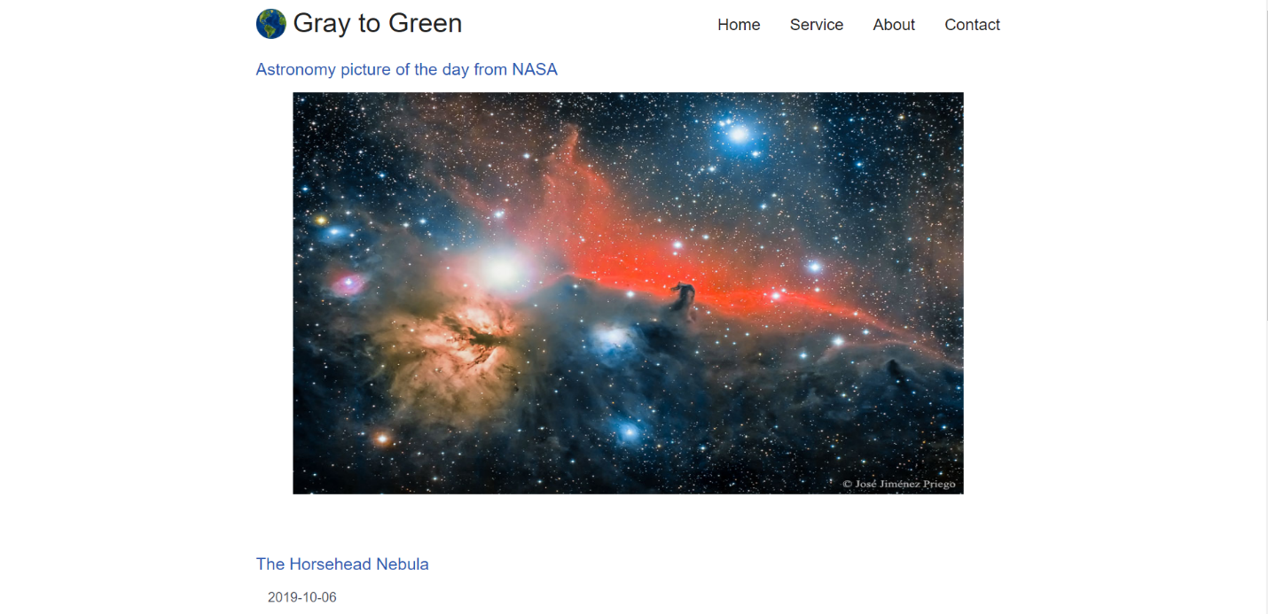

1. Contacts for sending notification.

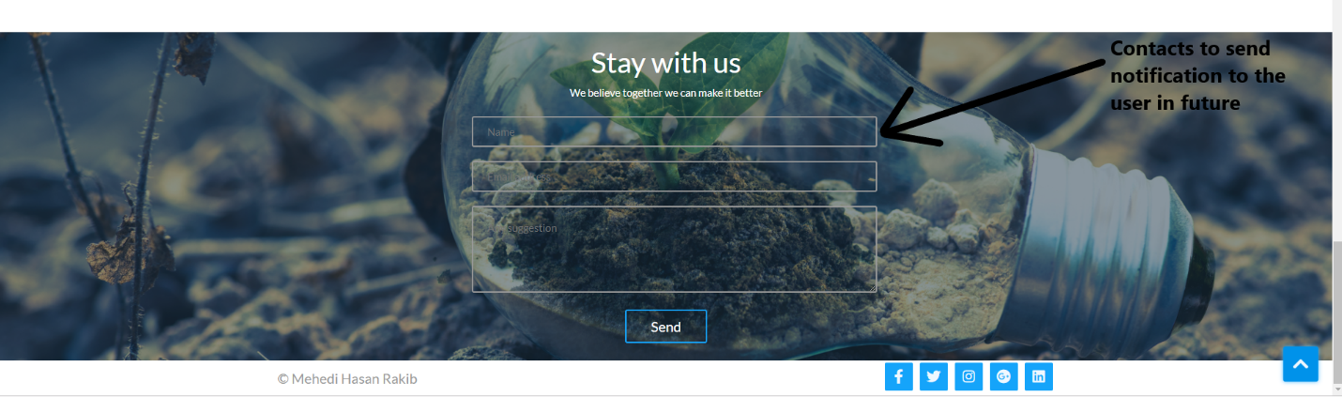

**What we could not do -**

We created a prototype showing how it will work and we are working on it they are-

Showing how the algorithm is working as it takes time to set up the algorithm.